**ITS 26000 – Applied Database Tech**

**Lab 07 – (100 points)**

**Use SQL to complete the following exercises.**

### **KimTay Pet Supplies:**

* 1. For the below example, the two ways are listed below to select the invoice information.
* SELECT INVOICE_NUM, INVOICE_DATE

FROM INVOICES

WHERE INVOICE_NUM IN (SELECT INVOICE_NUM

FROM INVOICE_LINE

WHERE (ITEM_ID =‘KH81’) );

* SELECT INVOICE_NUM, INVOICE_DATE

FROM INVOICES

WHERE EXISTS (SELECT*

FROM INVOICE_LINE

WHERE (INVOICES.INVOICE_NUM = INVOICE_

LINE.INVOICE_NUM)AND(ITEM_ID =‘KH81’);

Write the above query by using joins between the tables. (10 points)

select invoices.invoice_num, invoices.invoice_date

from invoices, invoice_line

where invoice_line.item_id = 'KH81' and invoice_line.invoice_num = invoices.invoice_num;

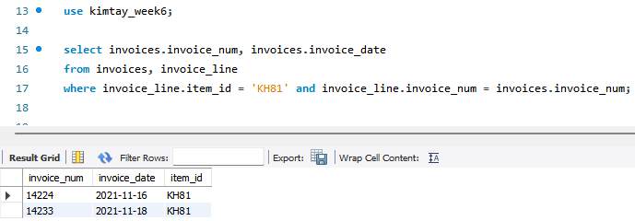

* 1. For each invoice placed on November 15, 2021, list the invoice number along with the ID, first name, and last name of the customer for which the invoice was created. (10 points)

select invoices.invoice_num, customer.cust_id, first_name, last_name

from invoices, customer

where invoice_date = "2021-11-15" and customer.cust_id = invoices.cust_id

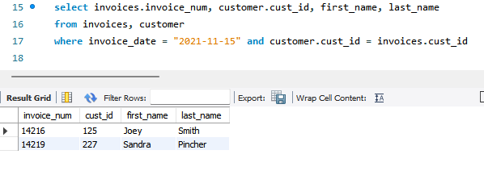

* 1. Use the IN operator to find the ID, first name, and last name of each customer for which as invoice was created on November 15, 2021. (5 points)

select customer.cust_id, first_name, last_name

from customer

where customer.cust_id IN (select cust_id

from invoices

where invoice_date = "2021-11-15")

* 1. Use the EXISTS operator to find the ID, first name, and last name of each customer for which as invoice was created on November 15, 2021. (5 points)

select customer.cust_id, first_name, last_name

from customer

where exists (select cust_id

from invoices

where invoice_date = "2021-11-15" and customer.cust_id = invoices.cust_id);

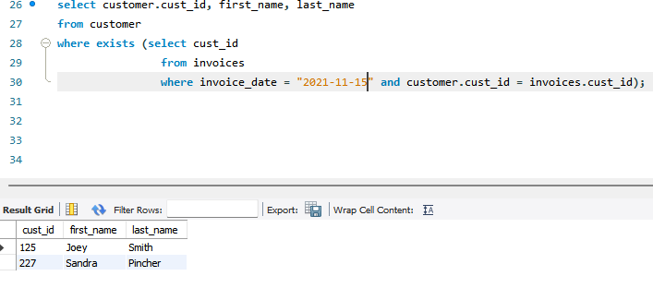

* 1. Find the ID, first name, and last name of each customer for which an invoice was not created on November 15, 2021. (10 points)

select customer.cust_id, first_name, last_name

from customer, invoices

where invoices.invoice_date <> '2021-11-15' and invoices.cust_id = customer.cust_id;

* 1. Use a subquery to find the sales rep ID, first name, and last name of each sales rep who represents at least one customer with a credit limit of $500. List each sales rep only once in the results. (10 points)

select a.rep_id, a.first_name, a.last_name

from sales_rep as a

where rep_id in (select distinct(rep_id)

from customer

where credit_limit = 500);

* 1. Use joins to find the sales rep ID, first name, and last name of each sales rep who represents at least one customer with a credit limit of $500. List each sales rep only once in the results. (10 points)

select distinct(a.rep_id), a.first_name, a.last_name

from sales_rep as a, customer as b

where b.rep_id = a.rep_id and b.credit_limit = 500;

1. **StayWell Student Accommodation:**
   1. For every property, list the management office number, address, monthly rent, owner number, owner’s first name, and owner’s last name. (10 points)

select office_num, property.address, monthly_rent, property.OWNER_NUM, owner.FIRST_NAME, owner.LAST_NAME

from property, owner

where property.OWNER_NUM = owner.OWNER_NUM;

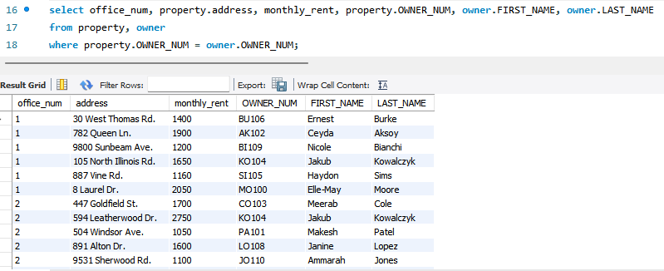

* 1. For every completed or open service request, list the property ID, description, and status. (10 points)

select property_id, description, status

from service_request

where status in ("Open", "Completed");

* 1. List the first and last names of all owners who own a two-bedroom property. Use the IN operator in your query. (10 points)

select first_name, last_name

from owner

where owner_num in (select owner_num

from property

where BDRMS = 2);

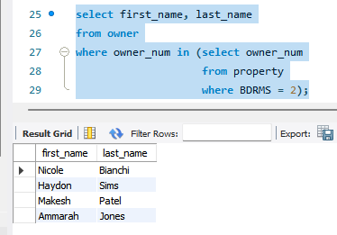

* 1. List the first and last names of all owners who own a two-bedroom property. Use the EXISTS operator in your query. (10 points)

select first_name, last_name

from owner

where exists (select owner_num

from property

where BDRMS = 2 and owner.owner_num = property.OWNER_NUM);

**Deliverables**: Document Report with the SQL statement/Query and snapshot of query, its execution and results. Either word or pdf file need to be uploaded into Brightspace in one submission